Prototype screenshots: Evan

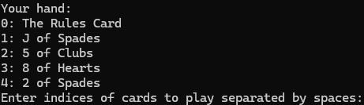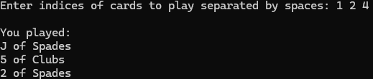
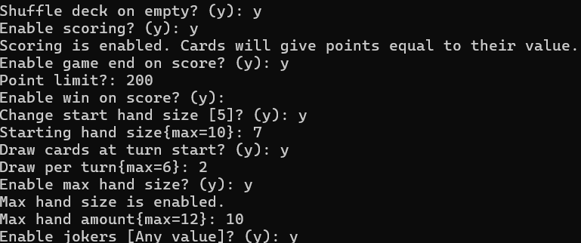

These are screenshots of the earliest version of the game where I was testing game logic before putting it into unity. This version had limited rules, as seen in screenshot above, and was quickly moved over to unity so that testing can be done for the game's ui.

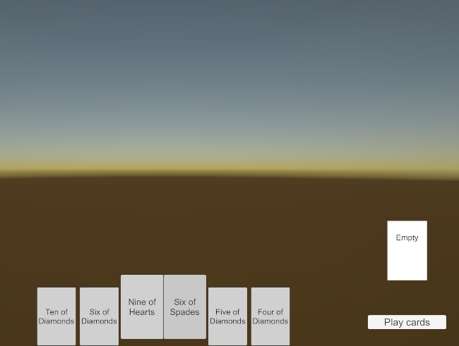
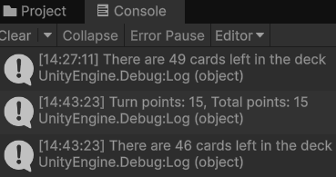

These screenshots show the earliest version of the unity build of the game, alongside the console. This version didn’t have an AI to play against yet and had no art or models for anything. This was because we had not yet merged and connected the different builds together. It did keep all of the rules from the previous version, all of which worked for one player.

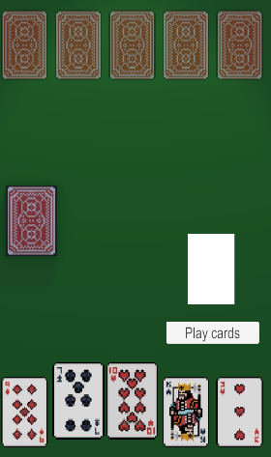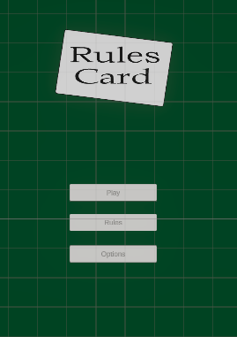
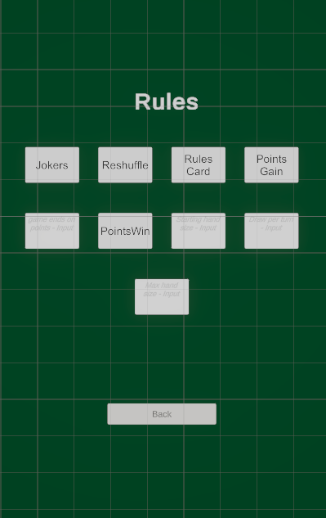

The next prototype was after all the different aspects of the projects had been merged together. This included a menu screen, card art, animations, the AI, and the models. No new rules beyond the original rules had been created yet, but the rules that did exist were adapted so that they also worked with the AI that was now in the game.

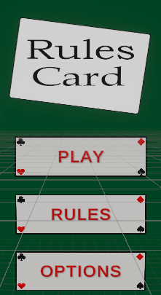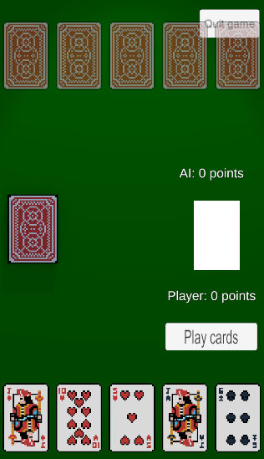
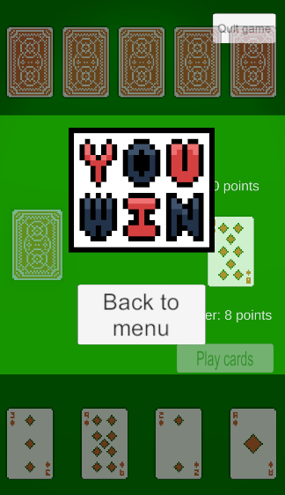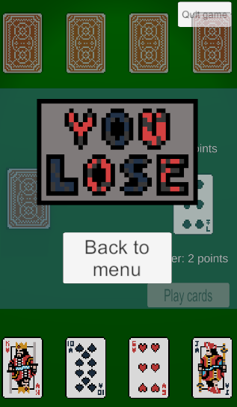

In the next prototype the menu was adjusted to look nicer, a quit button was added to the play scene, alongside adding visual displays for some of the rules where the user would need to know additional information(points, etc). 6 new rules were also added for this prototype, making the total number of rules 15. On top of this, the game now has a screen to show the user when they have won or lost the game.

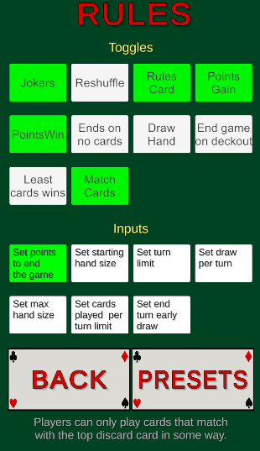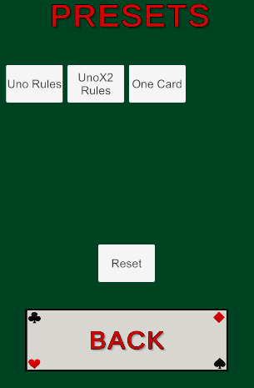

For the final prototype of the game, even more rules were added, bringing the total to 17, alongside adding a presets buttons where the user is able to choose from a premade set of rules if they don’t want to go through the trouble of making their own ruleset. Each rule was also given a description text to make it clear to the user what the rule does.

